Contents

Task No. 1 (Create following table:) 2

Task No. 2 (Create a form for inserting Faculty details in Access Database.)…………………3

Task No. 3 Create suitable report of the given database that shows all the records)…………..4

**Task # 01:** Create following table:

**Table Name:** Faculty

**Column 1:** Faculty_Id (AutoNumber) PK

**Column 2:** Name (Short Text)

**Column 3:** Designation (Short Text)

**Column 4:** Contact No (Number)

**Column 5:** City (Lookup Wizard)

**Column 5:** Dept_Name (Lookup Wizard)

**Column 6:** Picture (Attachment)

Insert three records into this table and save the results.

Solution:

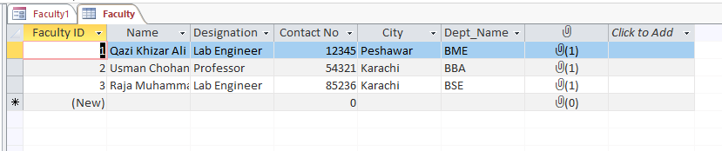

**Task # 02:** Create a form for inserting Faculty details in Access Database.

**Table Name:** Faculty.

Solution:

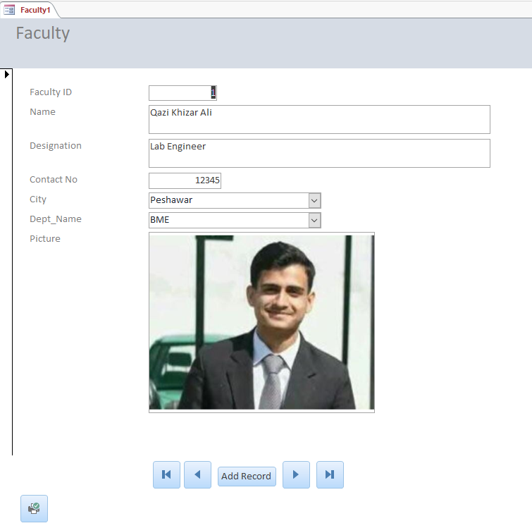

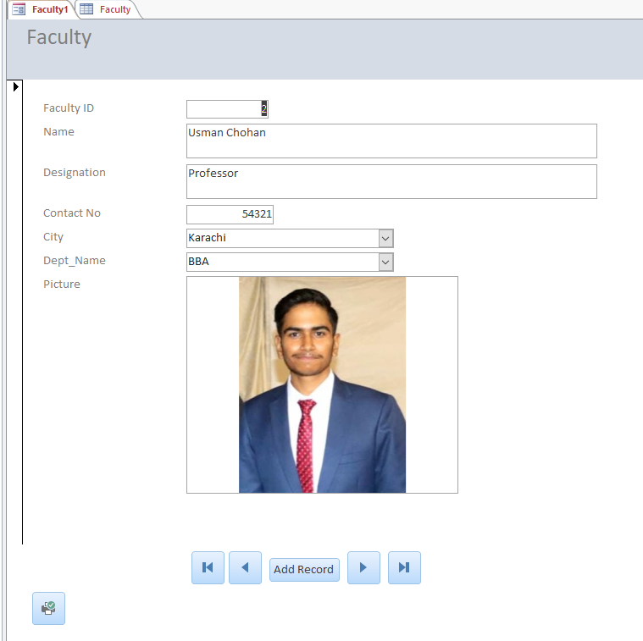

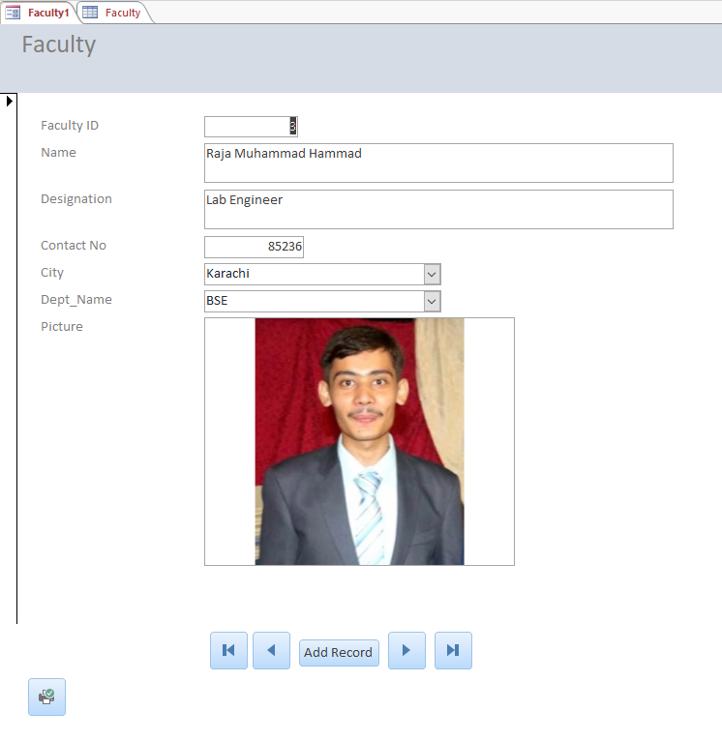

**Task # 03:** Create suitable report of the given database that shows all the records stored in the table.